# **Child protection risks across The consortium**

Dominik Bulla,

(dominik.bulla@gmail.com)

31st March 2023

## Introduction and background

The Consortium is a multi-country project funded by a big European country. The project has brought together the six largest child rights organisations of that country, to improve the protection of vulnerable children and adolescents living in refugee and internally displaced person (IDPs) settings and host communities across different locations within Bangladesh, Burkina Faso, Central African Republic, Colombia, Ethiopia, and South Sudan. The target groups included children and adolescents with disabilities, girls and boys under 18 years of age, and survivors of gender-based violence. Each of the six organization implemented the project in two of the six different project countries resulting in 12 implementing partners in total. The project kicked off in July 2022 and has a total duration of 24 months.

The project evaluation design is centred around a pre/post comparison in which project attainment will be measured at midline as well as endline and then compared with the baseline values for a set of the following three outcome indicators:

1. % of children who report increased knowledge of child protection risks and how to stay safe due to participation at endline
2. % of caregivers who report increased knowledge of caring and protection behaviours towards children under their care compared to the beginning of the project
3. % of community members who report increased confidence in their ability to prevent and respond to child protection risks compared to the beginning of the project

To obtain initial values on these three outcome indicators, a baseline study was carried out across the project locations within the six countries between November 2022 and January 2023. The baseline study provided quantitative insights especially into knowledge and awareness levels around child projection risks and behaviours within target communities. The main exercise of the baseline study was a multi-topic household level survey that was implemented in country by local consultants within each project countries and designed and coordinated by an international consultant located at the global level of the consortium.

As part of the quantitative baseline exercise, socio-demographic data of caregivers were collected. The consortium was interested in the socio-demographics of caregivers not only at the in-country level of partners but also at the global level. For example, it was of interest to find out the global average of caregivers that were working at baseline. It would eventually enable the consortium to determine any socio-demographic changes amongst others concerning caregivers between baseline and endline. The excerpt presented here presents key findings on the socio-demographics of caregivers both at the partner level as well as the global level. To obtain accurate global averages of the socio-demographics of caregivers sampling weights were calculated and applied. The analysis was performed in R (The R Core Team, 2019) using different packages.

## The construction of sampling weights

The baseline survey was implemented in country through local consultants and coordinated by an international consultant at the global level. In country, local consultants were instructed to perform multi-stage sampling to obtain nuanced and representative results on the people of concern, i.e., refugees, IDP’s and the host communities the implementing partners are working with in country.

Table 1: The project population by implementing partner and people of concern

The actual sample size carried out, however, was not only the product of methodological concerns. It was also the result of budget constraints resulting in baseline samples that varied across partners in terms of size. Also, the implementation of the baseline survey in country results in over- and under-sampling of certain groups of concerns. To adjust for over- and under-sampling of groups of concerns sampling weights were calculated and applied to the descriptive analyses of the baseline data. Sampling weights are used to adjust for unequal probabilities of selection in a sample. They allow each observation to represent a larger or smaller share of the population, based on its selection probability.

Sampling weights were also applied to the descriptive socio-demographic statistics determined for the global level. Again, due to the variations in baseline sample size between partners, some in-country populations of interest were over- or undersampled. To calculate the sampling weights, the proportion of the global sample in each stratum were compared to the actual proportion of the population. As for the global analysis of socio-demographics of caregivers, the type of household (i.e., refugees, IDP’s and the host communities) as well as the implementing partner working with the household were considered only. This amounted to 36 strata in total. Table 1 on the previous page provides an overview on the absolute numbers within each stratum. Across all six countries and sub-groups, the consortium has been targeting 391,208 households in total.

Table 2: The baseline samples by implementing partner and people of concern

Table 2 presents the effective baseline sample size reached for each sub-group in each of the six project countries. Across all countries and sub-groups, 5283 households were surveyed. The sampling weights to determine global averages were calculated as follows: $\left(global\right) sampling weights= \frac{population proportion}{sample proportion}$. To do so, the counts of table 1 and table 2, respectively, were turned into proportions first. Table 3 on the next page presents the calculating global sampling weights. Applying these global sampling weights allowed turning the baseline data into a complex survey design and then estimating weighted global averages. To do so, the package ‘survey’ (Lumley, 2020) was employed

Table 3: The baseline sampling weights for the different strata

## The socio-demographics of caregivers

Analysing the baseline results provides socio-demographic overviews of caregivers supported by the project both at the partner level as well as global level. Table 4 on the next page presents the results. In terms of the global averages, both weighted as well as unweighted results were included. To obtain the weighted averages, the methodology outlined in the previous section was applied.

As table 4 highlights, the differences between weighted and unweighted averages are not stark but discernible, nonetheless. For example, the global average of caregivers that are not married, divorced, or widowed (i.e., single) appears to be almost three percentage points lower in the weighted compared to the unweighted case. By contrast, the share of caregivers with disabilities is almost two percentage points higher. Given an overall average share of around 15 percentage, this matters. At the global level, the standard errors (‘se’) appear to be smaller compared to the within-country cases. This is explained by the fact that the standard errors are always a function of the sample size. Thus, the larger the sample the smaller the standard error associated with a statistic if all other things are kept equal.

Table 4: Selected socio-demographic characteristics of caregivers surveyed (n = 5283)

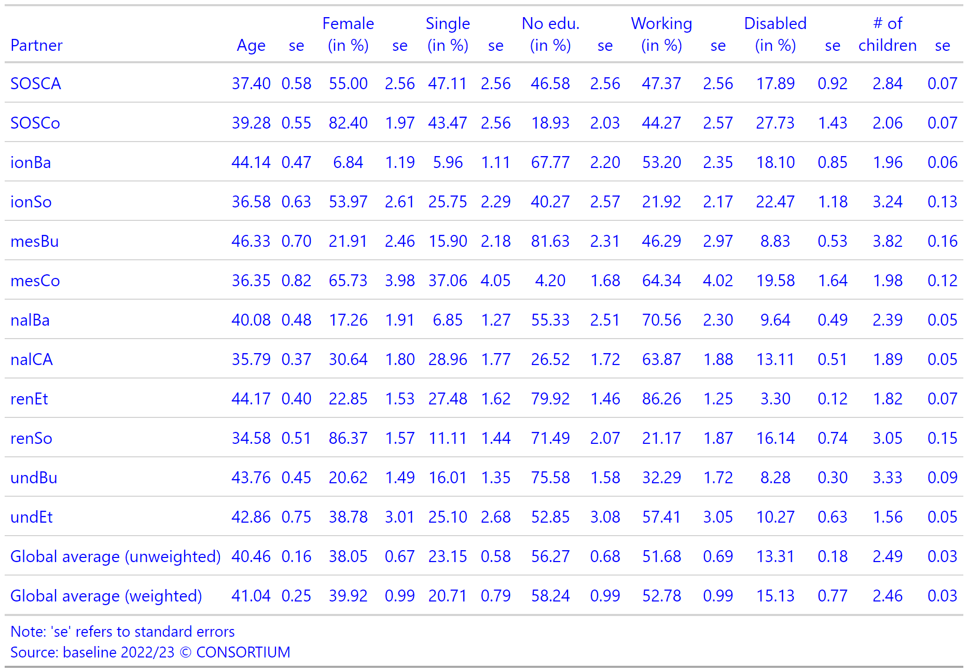

Table 4 also highlights that the socio-demographic characteristics of caregivers associated with the different implementing partners vary. For example, in the case of renET, only about 3.3 percent of caregivers self-reported to be with disabilities. By contrast, in the case of SOSCo the share of caregivers with disabilities amounts to almost 28 percent. It highlights the stark variation of ground-level realities across the 12 project locations. This is no surprise given that the project locations are across six different countries within three continents altogether.